1. **Agenda**:
   1. Let us see all the producer configurations when running the producer.
2. 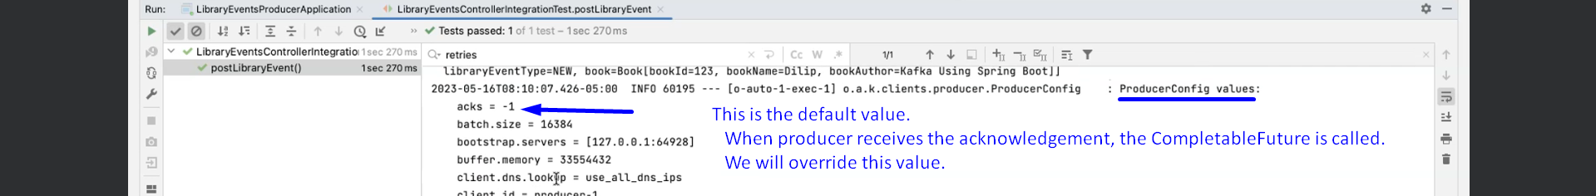  
   Actually, CompletableFuture, we discussed when writing Spring Kafka Application earlier.
3. 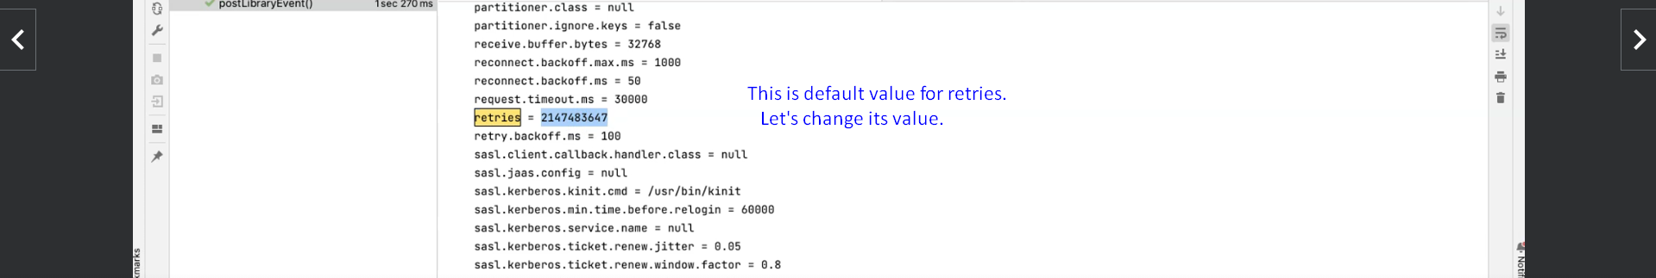
4. c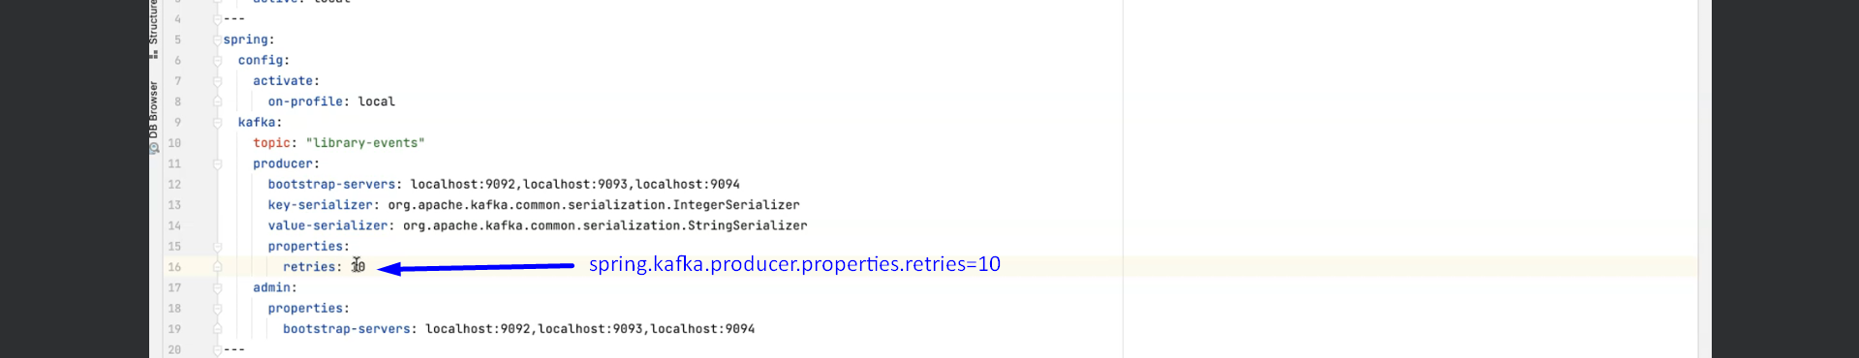  
   Some producer properties are defined under spring.kafka.producer where as the properties defined spring.kafka.producer.properties are passed directly to underlying kafka. Spring Kafka doesn’t do anything with this property. This is called **Pass-Through Configuration mechanism**.
5. 